**Tableau 2020.2 New Features**

**Server or site administrator**

* [New Admin Views](https://help.tableau.com/current/server/en-us/whatsnew_server.htm#NewAdminViews)
* [Changes to Create and Modify Schedule](https://help.tableau.com/current/server/en-us/whatsnew_server.htm#create-modify-schedule)
* [Data Acceleration](https://help.tableau.com/current/server/en-us/whatsnew_server.htm#data-acceleration)
* [Extract Query Load Balancing](https://help.tableau.com/current/server/en-us/whatsnew_server.htm#load-balancing-eq)
* [Dynamic Configuration](https://help.tableau.com/current/server/en-us/whatsnew_server.htm#dynamic-config-20-2)

**New Admin Users:**

Two new administrative views were added.

1. [Backgrounder Dashboard](https://help.tableau.com/current/server/en-us/adminview-backgrounder-dashboard.htm)**.**

Use this view to understand the background job details such as,

* + The time it takes for jobs to run.
  + When backgrounder is busy or overloaded.
  + Jobs that completed successfully, failed, or canceled.

1. Stale Content aka Stats for Unused Content:

Identify content that hasn't been accessed or opened in a while and how much disk space is being used by stale content.

In previous versions of Tableau Server, admin views were all displayed in the same workbook, in separate tabs. However, the two new admin views are displayed as separate workbooks and not part of the existing admin view workbook. You can navigate to the new admin views from the Server or Site Status page

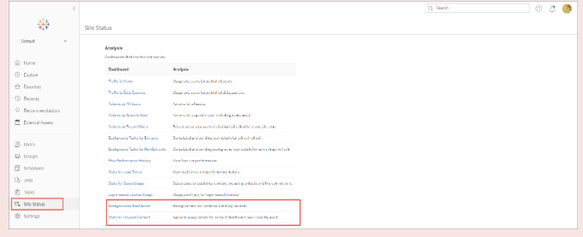

# **Create or Modify a Schedule**

The Schedules page is accessible only by Tableau Server Administrators. It shows a list of schedules, including their name, type, what they’re for (scope), the number of tasks, behavior (concurrent or serial processing), and when they are scheduled to run.

Creating a Schedule:

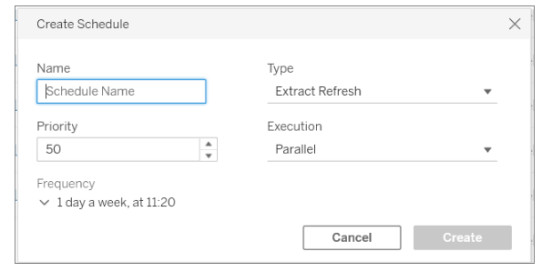

Modify Schedule:

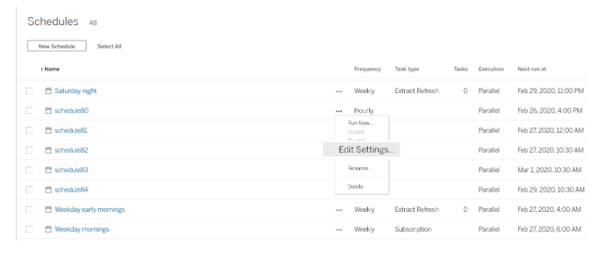

## **Rules for Creating or Modifying Schedules:**

* Schedules that run every 15 or 30 minutes must have start and end times that are on the hour. Examples of on the hour: 5:00 AM to 6:00 AM.
* Daily schedules on any recurrence must have the same start and end minute. For example, 10:35 am to 4:35 pm. The hour can be different. However, if the daily schedule is set to only happen once a day, it needs only a start time and not an end time.

### Analytics extensions (external service) connections must be reconfigured

Tableau supports a set of functions that your users can use to pass expressions to analytics extensions for integration with R and Python. Previously, this feature was referred to "external services."

In previous versions of Tableau Server, the analytics extensions configuration applied to the Tableau Server global configuration and was administered with TSM.

Before upgrading, document the existing analytics extensions configuration. On previous versions (2019.1-2020.1) you can run the

**tsm security vizql-extsvc-ssl list** command to list the existing connection details.

**tsm configuration get -k vizqlserver.rserve.password** To retrieve the password that is stored for the analytics extensions connection (if any), run the following tsm command

# **Data Acceleration**

Administrators can enable data acceleration for specific workbooks to improve their performance.

[Extract Query Load Balancing](https://help.tableau.com/current/server/en-us/whatsnew_server.htm#load-balancing-eq)

Loading a published workbook or dashboard is a two-step process:

**query**: fetching the data needed after connecting to the underlying data source.

**rendering**: performing visual rendering such as layout, drawing shapes, assigning colors, and so on.

In Tableau Server version 2020.2 and later, load balancing for extract-based queries has improved and may result in faster load times for extract-based dashboards.

This feature is turned on by default. To disable it, use the following tsm commands:

**tsm configuration set -k hyper_standalone_consistent.hashing.enabled -v false**

**tsm configuration set -k hyper_standalone.health.enabled -v false**

Apply the changes using the following tsm command: **tsm pending-changes apply**

### **Dynamic Configuration**

Version 2020.2 introduces dynamic configuration for certain configuration options or keys.

This step toward more flexible server management includes dynamic configuration keys for changing logging levels for some Tableau Server processes, and changing some TSM base file paths.

Dynamically configurable keys include:

* **Tsm.log.level** -- Changes TSM logging levels for: clientfileservice, clustercontroller, licenseservice, tabadminagent, tabadmincontroller, tabsvc
* **Tsm.controlapp.log.level --** control applications
* basefilepath.site_import.exports
* basefilepath.site_export.exports
* basefilepath.backuprestore

**Resource Monitoring Tool (Changed Feature)**

The Master Server installer will first install certain prerequisites as the first step. The prerequisites include **RabbitMQ, Erlang, and a PostgreSQL** database. The PostgreSQL database is used to store usage data gathered from Tableau Server. It will then proceed to install the Master Server.

The Resource Monitoring Tool Master Server hosts the web application that users interact with. It also does much of the background processing to collate and monitor the data from the Agents. The Master Server must be installed on dedicated hardware.

To install Resource Monitoring Tool, you must have all the following:

* Administrator permissions on the machine you are installing Resource Monitoring Tool.
* Tableau Server Administrator site role.
* Resource Monitoring Tool Administrator account

**OS Requirements:** Starting in 2020.2, Windows Server 2012 is no longer supported. The minimum supported operating system is now Windows Server 2012 R2.